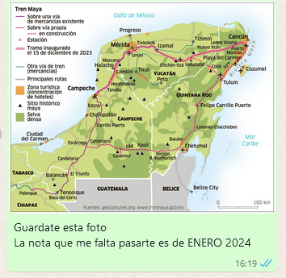


https://nuso.org/articulo/reforma-judicial-mexico-amlo-sheinbaum/


https://x.com/alfreserramanci/status/1832168740110168458?s=46&t=62BznkiAiq-9xT63PrQ8tQ
https://ar.radiocut.fm/audiocut/claudia-sheinbaum-es-muy-respetada-en-mundo-politica-internacional/

https://www.tiempoar.com.ar/ta_article/reforma-judicial-mexico-amlo-eeuu/
https://www.celag.org/?s=mexico


https://ar.radiocut.fm/audiocut/columna-jorge-duarte-6682/

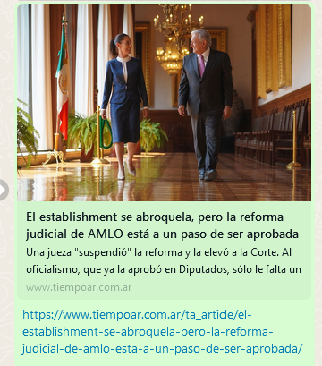

https://www.tiempoar.com.ar/ta_article/el-establishment-se-abroquela-pero-la-reforma-judicial-de-amlo-esta-a-un-paso-de-ser-aprobada/

https://cenital.com/elecciones-populares-de-jueces-donde-se-eligen-y-como-se-hace/

